**METROCAR**

**FUNNEL ANALYSIS**

Kalaivani Sankaralingam

25/11/2023

Table of Contents

Summary: 3

Test Details: 3

Test Objective: 3

Results: 4

Ride-Accepted to Ride-Completed Funnel Step: 4

Targeted Platform Marketing - iOS: 4

Age-Targeted Enhancements - 35-44 Age Group: 5

Surge Pricing Optimization - Winter Season: 5

Lowest Conversion Rate - Ride-Completed Step: 6

Recommendations: 6

Communication Improvements: 6

Incentives and Rewards: 6

Continuous Monitoring: 6

Encouraging Gratuity: 6

Optimizing Driver Allocation: 6

Conclusion: 6

Appendix: 6

Queries That Are Used In This Project: 6

Tableau Visualization: 6

Google Spreadsheets: 7

Google Spreadsheets Used For Business Question: 7

Summary: The Funnel Analysis Mastery Report delves into a comprehensive examination of the Metrocar ride-sharing app's customer funnel. By employing funnel analysis, the report identifies critical points for improvement and optimization, aiming to enhance the overall user experience. Key findings include a significant drop-off at the Ride-Accepted to Ride-Completed stage, iOS platform dominance in revenue, and age-specific revenue contributions.



Test Details: The analysis focused on the entire user journey within the Metrocar app, encompassing stages such as app download, signup, ride request, driver acceptance, the ride itself, payment, and review. The study involved data from a specified timeframe, considering user demographics and platform-specific metrics.

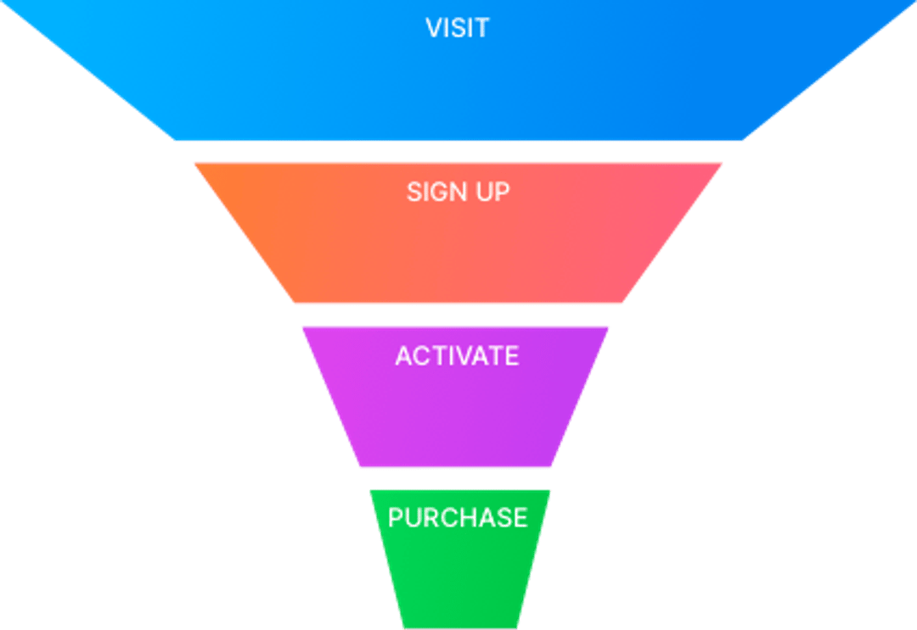

Test Objective: The primary objective was to pinpoint areas within the customer funnel that experienced notable drop-offs or inefficiencies. Additionally, the analysis aimed to identify platform-specific and age-group-specific trends to tailor strategies for optimization.

## Results:

### Ride-Accepted to Ride-Completed Funnel Step:

* Identified a severe drop-off of 49.23% in this crucial stage.

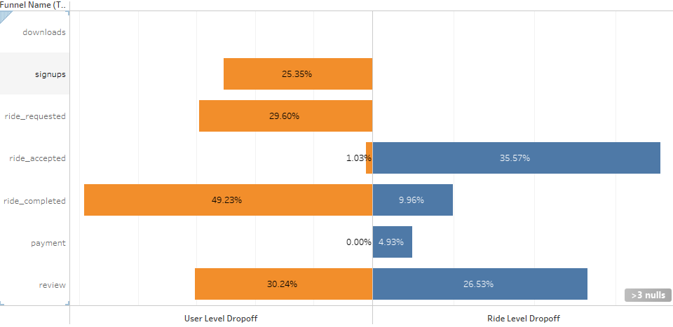

* + Lowest conversion rate observed at 50.77%.

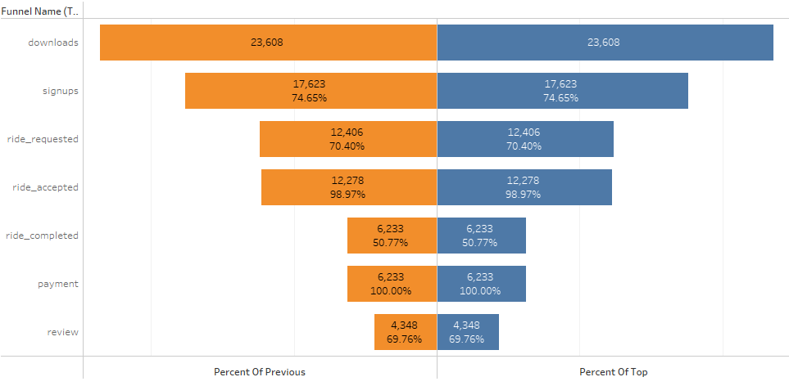

### Targeted Platform Marketing - iOS:

* + The iOS platform contributed the highest revenue share at 60.88%.

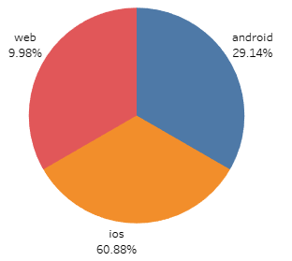

### Age-Targeted Enhancements - 35-44 Age Group:

* + The 35-44 age group demonstrated the highest revenue contribution, accounting for 29.63%.

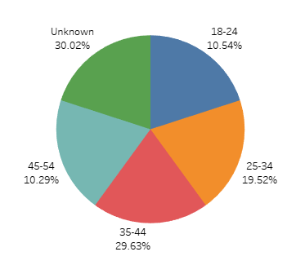

### Surge Pricing Optimization - Winter Season:

* + Higher revenue observed between November - January, suggesting a potential for surge pricing optimization during winter months.

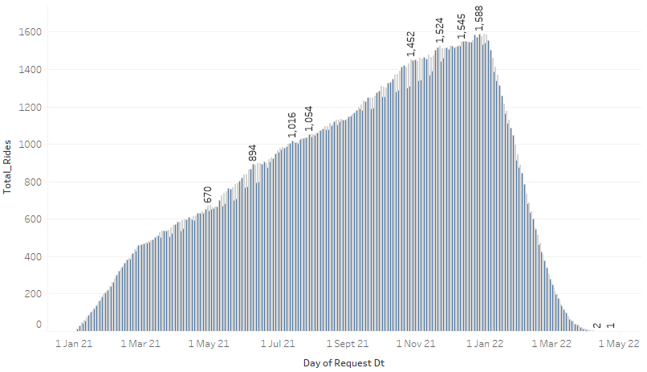

### Surge Pricing Optimization – Peak Hours:

* + Higher rides observed between 7 AM - 10 AM and 3 PM – 8 PM, suggesting a potential for surge pricing optimization during peak hours.

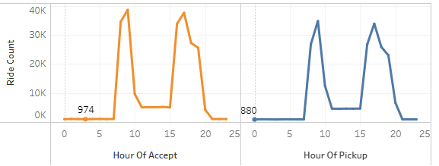

### Lowest Conversion Rate - Ride-Completed Step:

* + Lowest conversion rate observed in the transition from Ride-Accepted to Ride-Completed (50.77%).

## Recommendations:

### Communication Improvements:

* + Implement features to enhance communication between users and drivers, reducing uncertainty and friction points.

### Incentives and Rewards:

* + Introduce incentives for users and drivers to encourage positive behavior and completion of the ride process.

### Continuous Monitoring:

* + Regularly assess and iterate on implemented enhancements based on ongoing data analysis.

### Encouraging Gratuity:

* + Introduce Passenger Tips as a token of appreciation for drivers.

### Optimizing Driver Allocation:

* + Explore optimization of driver allocation algorithms or provide real-time updates on driver arrival to reduce user waiting time.

Conclusion: The Funnel Analysis Mastery Report provides actionable insights for Metrocar to optimize the ride-sharing experience. By addressing specific funnel stages and implementing targeted strategies, Metrocar can enhance customer satisfaction, increase conversion rates, and maximize revenue potential.

Top of Form

## Appendix:

### Queries That Are Used In This Project:

<https://docs.google.com/document/d/1rJpO76V68smKU4t2Xb3KULLyfvvm_2iz/edit?usp=sharing&ouid=115662457308512981509&rtpof=true&sd=true>

### Tableau Visualization:

* **Project Business Questions:**

<https://public.tableau.com/app/profile/kalaivani.sankaralingam/viz/Metrocar-Introduction/MetrocarRideSharingAppProject>

* **Funnel Dashboard Visualization:**

<https://public.tableau.com/app/profile/kalaivani.sankaralingam/viz/MetrocarFunnelMetrics-Dashboard/MetrocarFunnelMetrics>

* **Weekly Analysis Dashboard:**

<https://public.tableau.com/app/profile/kalaivani.sankaralingam/viz/WeeklyAnalysis-Dashboard-Metrocar/WeeklyAnalysis-Dashboard-Metrocar>

* **Waiting Time And Cancel Status Dashboard:**

<https://public.tableau.com/app/profile/kalaivani.sankaralingam/viz/WaitingTimesAndCancelStatus-Dashboard/WaitingTimesAndCancelStatus>

* **Reviews Dashboard:**

<https://public.tableau.com/app/profile/kalaivani.sankaralingam/viz/Reviews-Dashboard/Review-Dashboard>

### Google Spreadsheets:

* **How many times was the app downloaded?**

<https://docs.google.com/spreadsheets/d/1cgIim1Di9anmQXZCXa0Q9DIbCw7T7NnKxxFvOM7mc38/edit?usp=sharing>

* **How many users signed up on the app?**

<https://docs.google.com/spreadsheets/d/1ihP4tDKpHuSpaUoEkV3j0Bqs6rCk-HJcC5HgJML2aJg/edit?usp=sharing>

* **How many rides were requested through the app?**

<https://docs.google.com/spreadsheets/d/18lDRFwQ6P-Lvo97maRqzj_eZZBs2z6Nq7v8nw8PPS60/edit?usp=sharing>

* **How many rides were requested and completed through the app?**

<https://docs.google.com/spreadsheets/d/1dT9N5_DbS83AGQuebsh6z7sSey-L59_CHAfvlDpRO7I/edit?usp=sharing>

* **How many rides were requested and how many unique users requested a ride?**

<https://docs.google.com/spreadsheets/d/1YFXFnGhxzSLMOKqxDTxT9EC83U_THeS3x0qrcxX-f4M/edit?usp=sharing>

* **What is the average time of a ride from pick up to drop off?**

<https://docs.google.com/spreadsheets/d/1NbID1kVKFFy-anq6fwGPnBBPHa2z3OJr46QmXXPveyQ/edit?usp=sharing>

* **How many rides were accepted by a driver?**

<https://docs.google.com/spreadsheets/d/1Grcn3k_VWooy6igz7UKF5HkK_ns-Fi1ebMW6vjlmHlk/edit?usp=sharing>

* **How many rides did we successfully collect payments and how much was collected?**

<https://docs.google.com/spreadsheets/d/1BRO9KPvVfcmhIKB0a3QyBUivpPTeGD0cnhoiAJSA0oE/edit?usp=sharing>

* **How many ride requests happened on each platform?**

<https://docs.google.com/spreadsheets/d/1jdn4FADE72wHAzQAyF5W1YqZj4KWRnKIX88LLW-VZi4/edit?usp=sharing>

* **What is the drop-off from users signing up to users requesting a ride?**

<https://docs.google.com/spreadsheets/d/1jLoWPHZEf5Jrl58lUgDJsMe-rudhhYBP_0-QWVca89c/edit?usp=sharing>

### Google Spreadsheets Used For Business Question:

* **Total Extracted Analysis For Funnel Visualization:**

<https://docs.google.com/spreadsheets/d/1xH8HCIlGp82NVflVfyHYmiyJdGbZwGXuRC4x2pAs25U/edit?usp=sharing>

* **Weekly Analysis:**

<https://docs.google.com/spreadsheets/d/1OehuF-wY6QSCMX8qopg_bNq08gHvV-IHzqzJezOxRwY/edit?usp=sharing>

* **Approved Payments And Average Rating:**

<https://docs.google.com/spreadsheets/d/1KkG0XpcnEXfVUymu5bhU3KslCk7Z_-vHzc4dbk54_bU/edit?usp=sharing>

* **Request Vs Accept , Accept Vs Pickup:=**

<https://docs.google.com/spreadsheets/d/1OpKfkk-Ja212ol4VttDtffSSuvFuTJgazDRYgndac8E/edit?usp=sharing>

* **Average Pickup Waiting time:**

<https://docs.google.com/spreadsheets/d/1BRyjMOY0ovon4mNMTFjBJdTpZml_d-KXJN13qY21frw/edit?usp=sharing>

* **Average Cancel Waiting time:**

<https://docs.google.com/spreadsheets/d/1io3wVpHEhNZ0F9DNKG8Ty7TAiG0ier3Fvc95sGnZB68/edit?usp=sharing>

* **Cancel Status:**

<https://docs.google.com/spreadsheets/d/13Ge0IAS4axjdLtyMdn1rxz_O1EFfVakku-G5hjsnn4o/edit?usp=sharing>

* **Review in Words:**

<https://docs.google.com/spreadsheets/d/1w-wtjz9esNL6MceQFZpOdSvl4s2Cb7Xw9PQ74vUJAqE/edit?usp=sharing>

* **Review RatingWise:**

<https://docs.google.com/spreadsheets/d/1vJP4QpIwA6zLbPRP38Fb3ScULbVt0ZtaU2suxvN2CZQ/edit#gid=1947450136>